___________________________________
___________________________________
___________________________________
___________________________________
The Most Dangerous Cask – Two-Faced Culminating Project
Due Thursday, October 16, 2014
Part One: Two-Faced Visual (50pts)

Directions: Use the silhouette provided (or draw your own visual) to complete the requirements for the project. Follow the instructions to write, draw, and quote one side of the face for Zaroff and the other for Montresor, creating the ultimate antagonist.

Each side of the face must include:

- One personality trait written in a complete sentence
  - (_____________ has a _______________ personality because ________________.)
- One reference to a conflict of the character
  - (_____________ has a conflict with _____________ because _________________.)
- At least three visual symbols for each the characters
  - The visual should be in color
  - The symbols should demonstrate the character’s personality, essence, and attitude.
  - You may also draw a visual representation of how you think the characters would look.
- Two of each characters’ most important quotes

Part II: SAQ (50pts)

In the space below answer the following question:
What are similarities between Zaroff and Montresor? Used text evidence to support your answer.
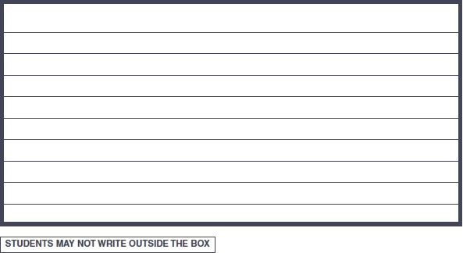

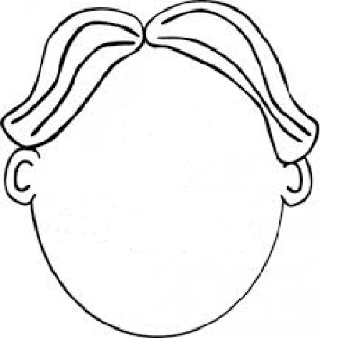

Rubric:
50 points – Head
- Personality trait 10 points ___________
- Conflict 10 points ___________
- Visuals 5 points each ___________
- Two quotes 5 points each ___________

50 points – SAQ (10 points each sections)

Score | Description | Grade
3 - Exemplary | Answer and evidence show a deep, insightful understanding of the texts. The answer is fully developed. | 3 = 50
2 - Sufficient | Answer and evidence show a good understanding of the text. The answer shows good development but could be improved. | +2 = 45  2 = 35  -2 = 25
1 – Partially Sufficient | Answer and evidence show a limited understanding of the text. There may be problems with the evidence used. The paragraph(s) may lack development. The paragraph does not adequately show a connection between the two texts. | +1 = 18  1 = 15  -1 = 10
0 – Insufficient | The answer does not show an understanding of the text. Text evidence and development are lacking. | 5 (with attempt)

